Cuvier’s

* ICI= 0.4-0.6 s
* Peaks at 18, 23, 33, and 39 kHz (39 kHz is the largest peak). I’ve also seen Zc peak at 36 kHz and the 18 and 23 kHz peaks are missing
* If using Pamguard, look for the little “tail” at the bottom right of the upsweep. Appears as a dot for off axis clicks
* Can be detected up to 5km away and group vocal periods can last on average 32min

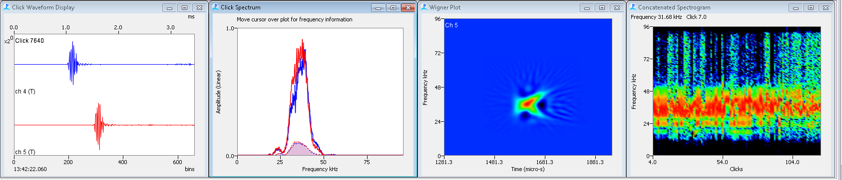 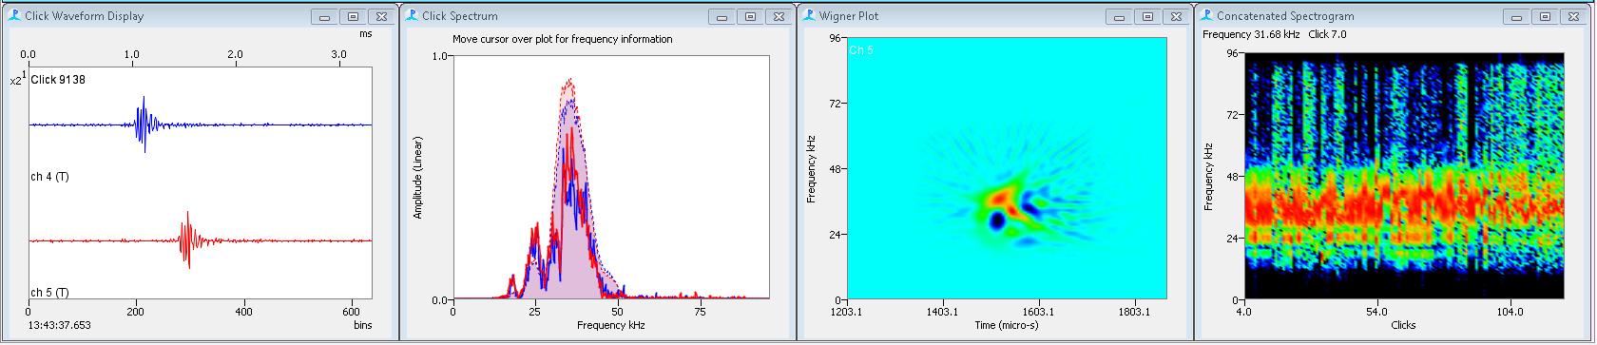

From NEFSC 2016 HTI data

tail

Sowerby’s

* These guys are hard to get, as their clicks are so high in frequency that the detection range is small. Click trains are less than a minute in duration with the vessel traveling at 10 knots so you have to be on your toes!
* ICI 0.1-0.2 s
* Peak between 64-66 kHz, look for an upsweep between 55 to 75 kHz

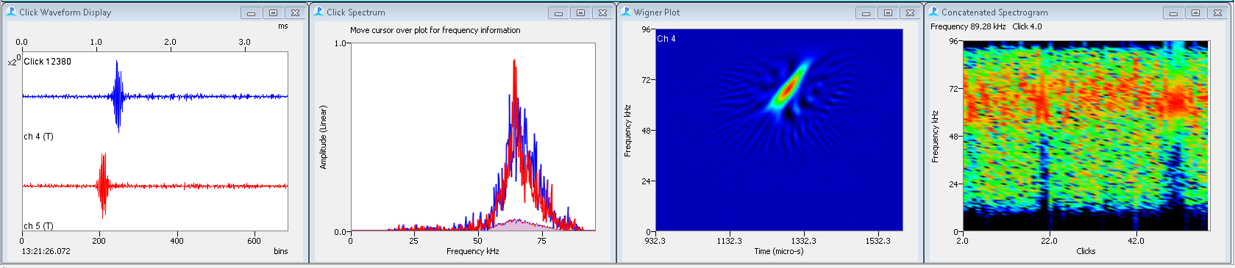 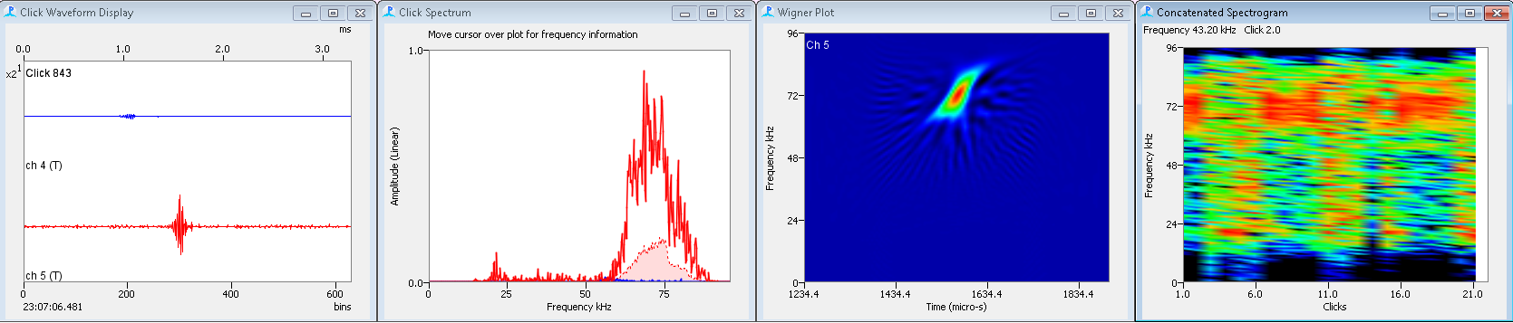

From NEFSC 2015 APC data

From NEFSC 2016 HTI data

Gervais’

* ICI ~0.27 s
* Starts at 30/33 kHz
* Peak around 38-40 kHz with a secondary peak at 46 kHz
* Average group vocal period 19-20 min

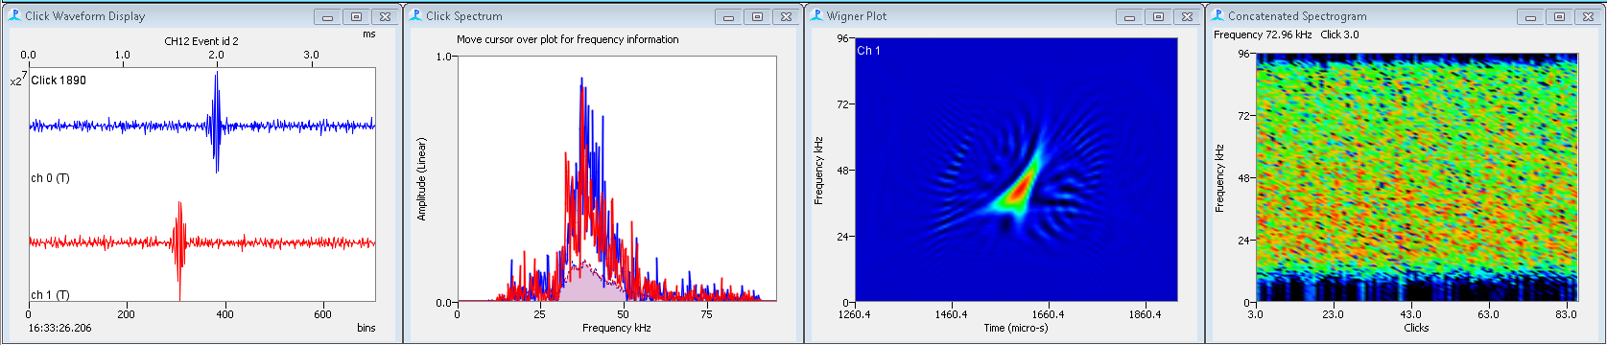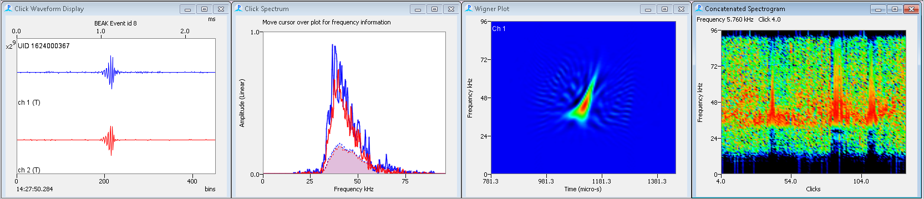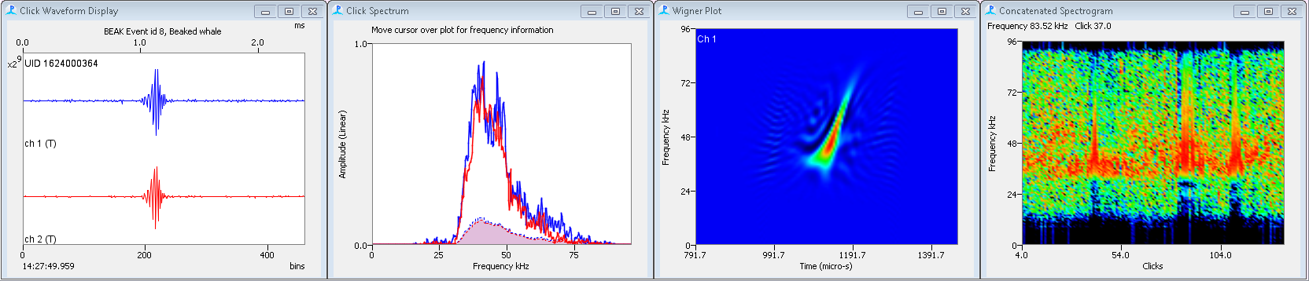

From SEFSC 2016 Resons

From SEFSC 2016 Resons

From Gillespie et al 2008

True’s

* Starts at 36 kHz
* ICI ~0.17 s
* Peak frequency ~45 kHz
* Vocal group period= 19min, silent descent= 4min, silent ascent= 10-12min, total individual dive time= 33min

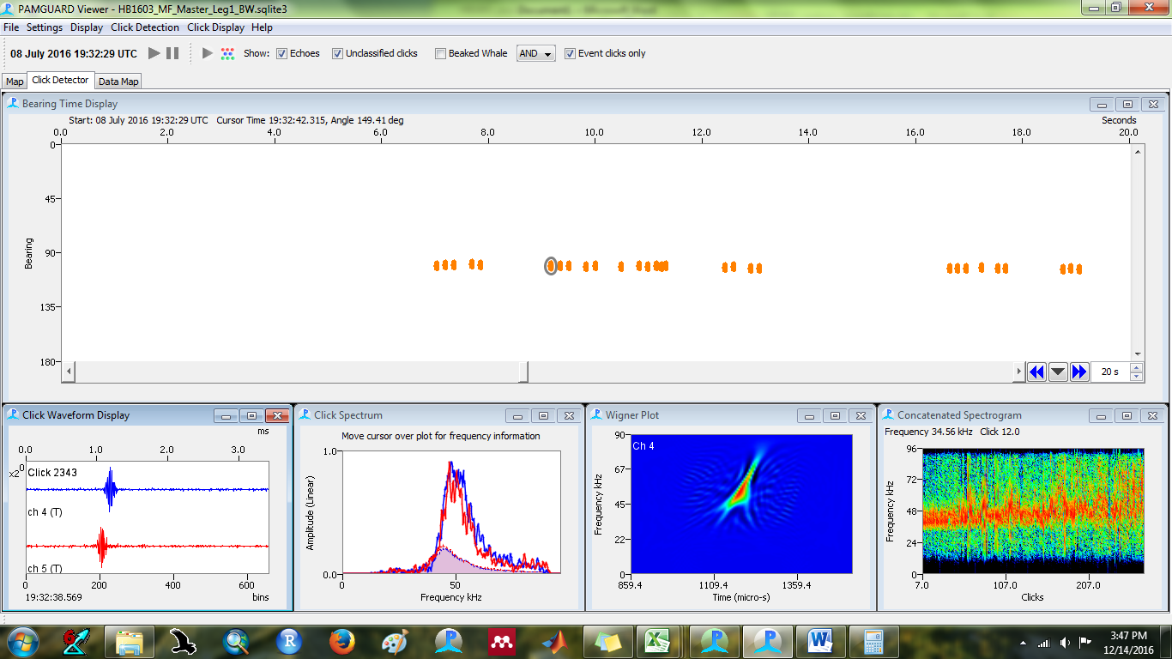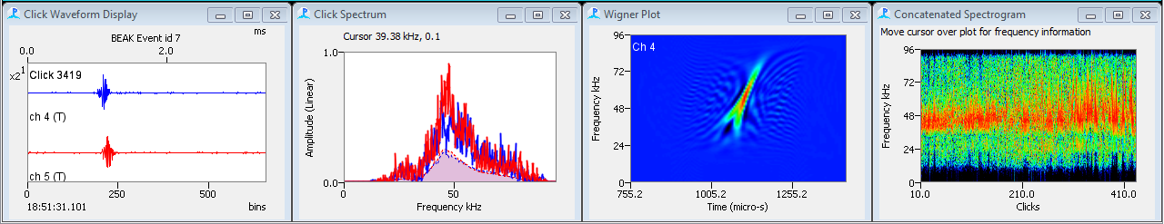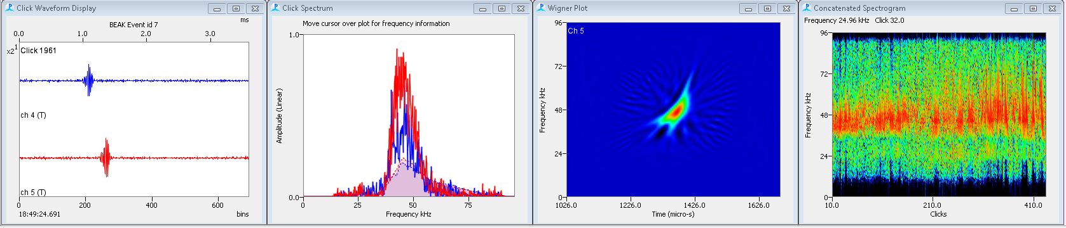

From NEFSC 2016 HTI data

Blainville’s

* Long in duration
* Starts at 26 kHz
* ICI= 0.2 – 0.4 s

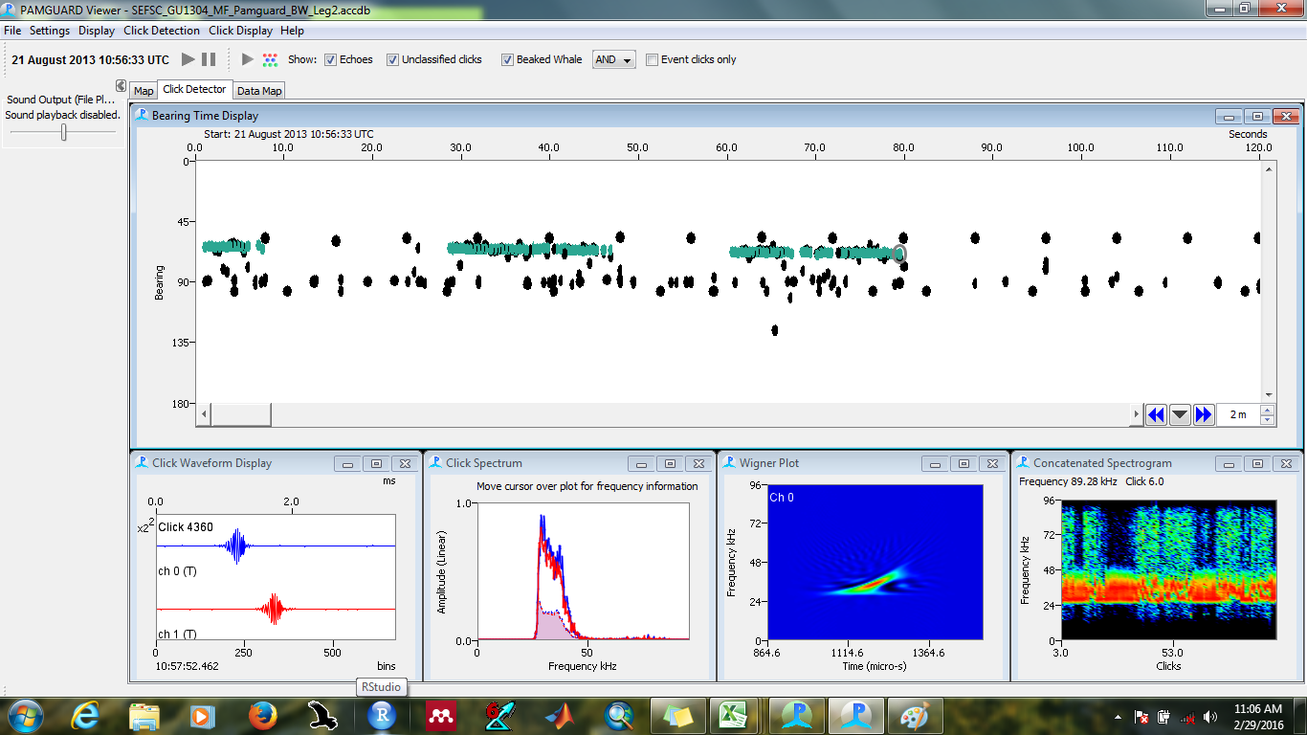

From SEFSC- AMAPPS 2013

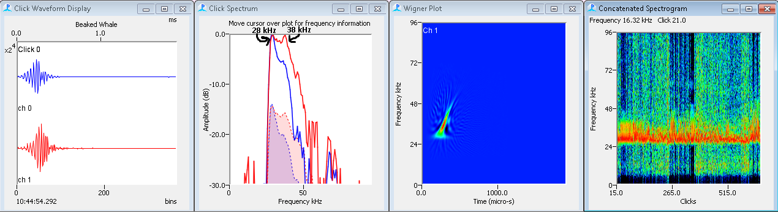

From Canaries- Izzi thesis

**ICI differences in real-time**

Cuvier’s

* Large spaces between clicks (very similar to sperm whales)

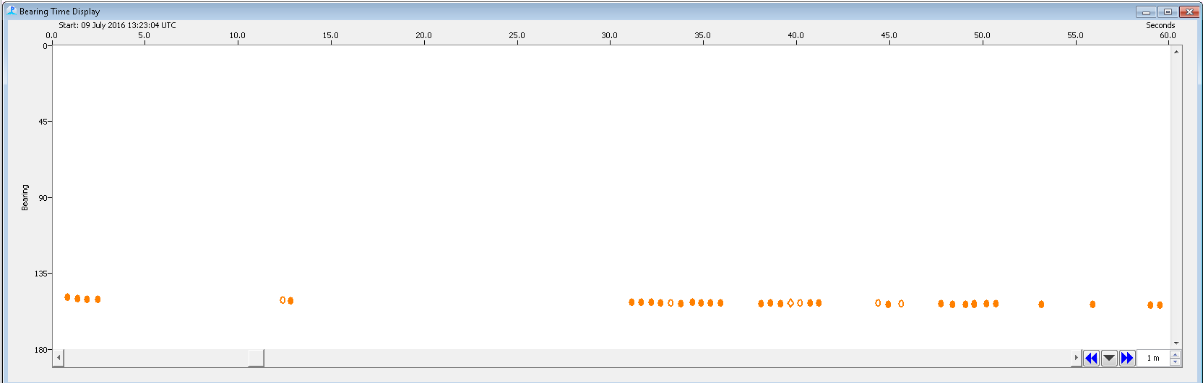

Sowerby’s

* Clicks are tightly spaced and click trains are very short

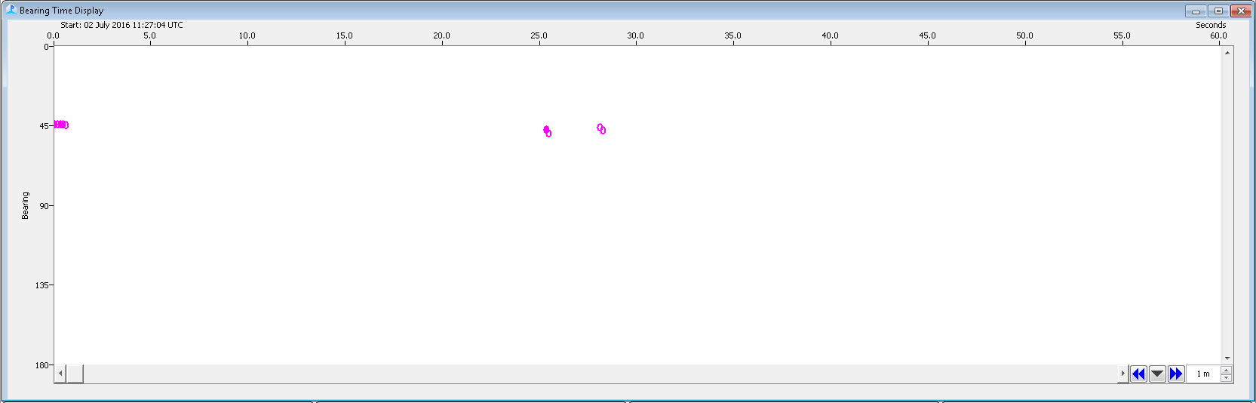

Gervais’

* Just enough of a gap between clicks to see the individual clicks

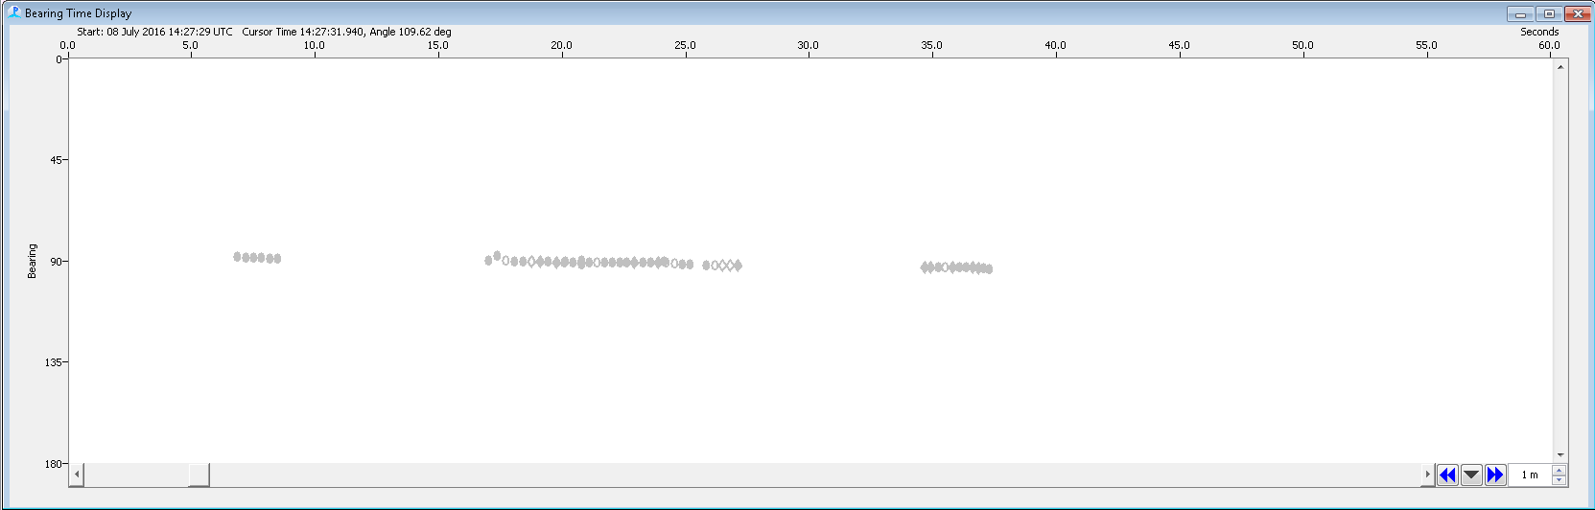

True’s

* Clicks are touching each other but not squished

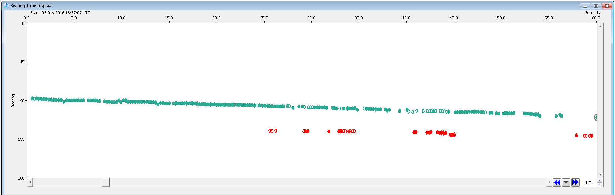

True’s (with log PSD scale, green= Gervais’ template, grey= True’s template)

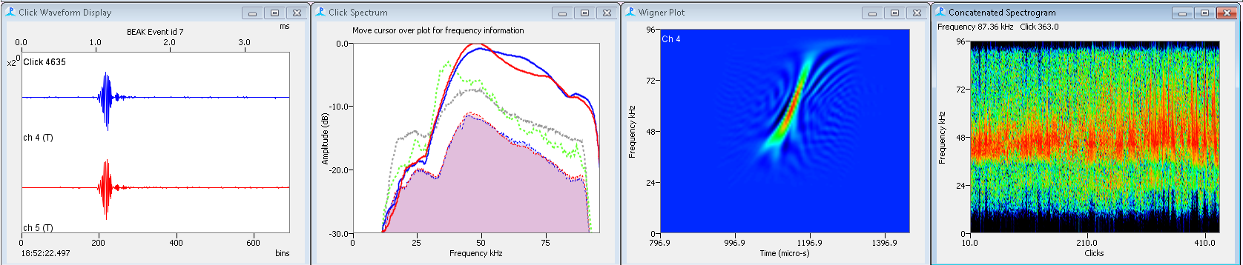

From NEFSC 2016 HTI data

Gervais’ (log scale, green= Gervais’ template, grey= True’s template)

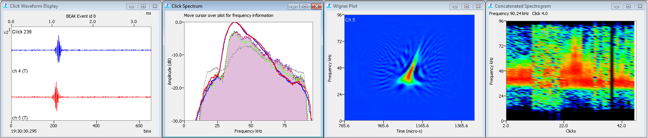

From NEFSC 2016 HTI data

Sowerby’s (log scale, green= Gervais’ template, grey= True’s template)

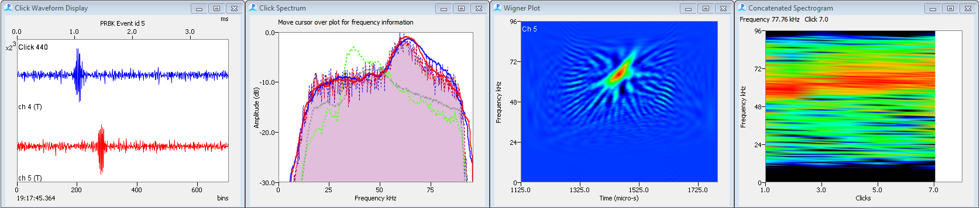

From NEFSC 2016 HTI data

Cuvier’s (log scale, green= Gervais’ template, grey= True’s template)

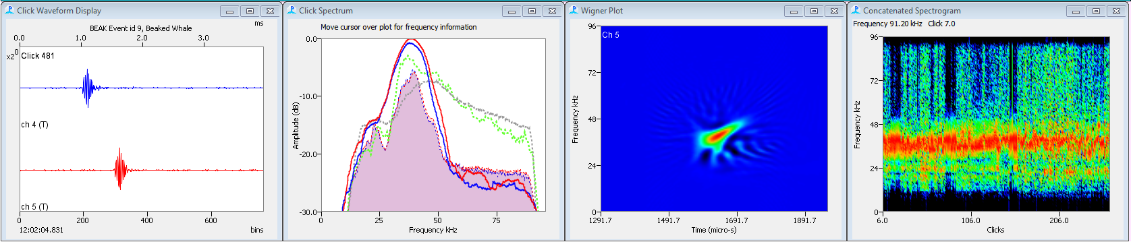

From NEFSC 2016 HTI data

Sowerby’s where the 27-28 kHz peak is larger than the 67 kHz peak (and sometimes the 67 kHz is missing)

